**Sample test Case**

1. **Add distributor**

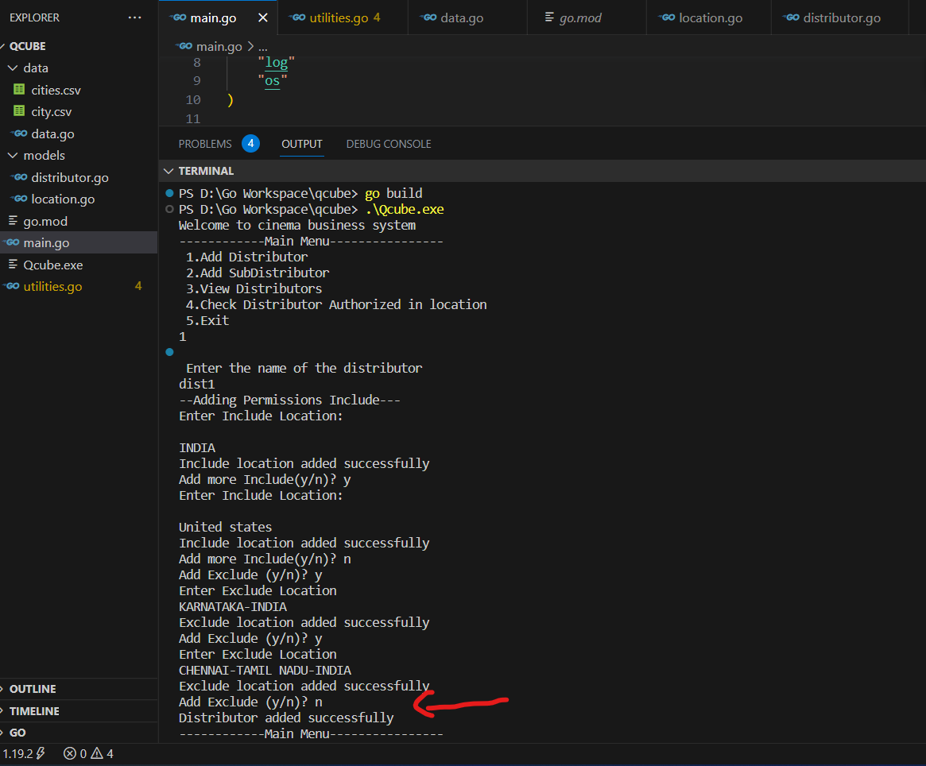

1. **Checking permission for Distributor 1 created in previous step**

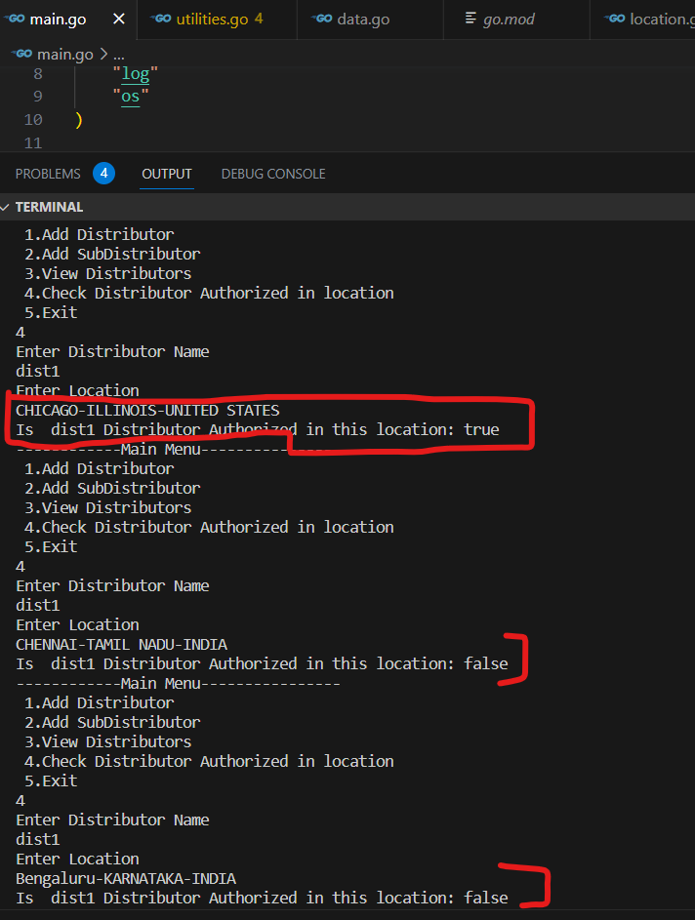

1. **Creating subdistributor:- DISTRIBUTOR2**

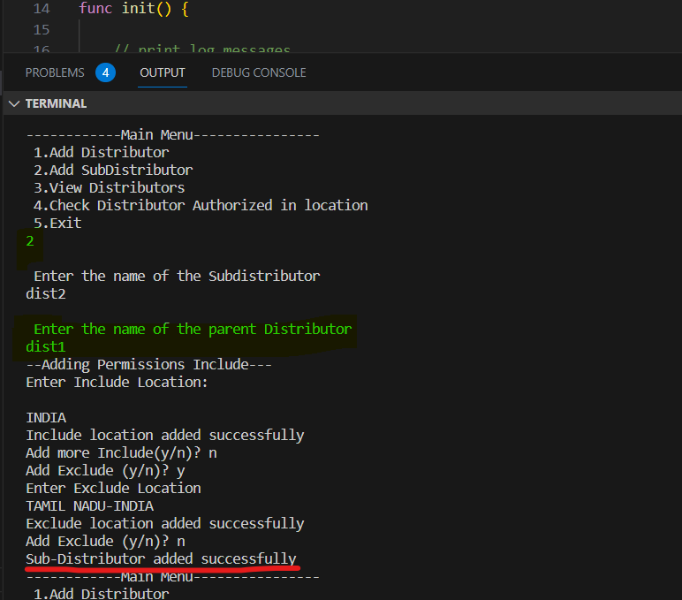

1. **Checking permission for distributor 2**

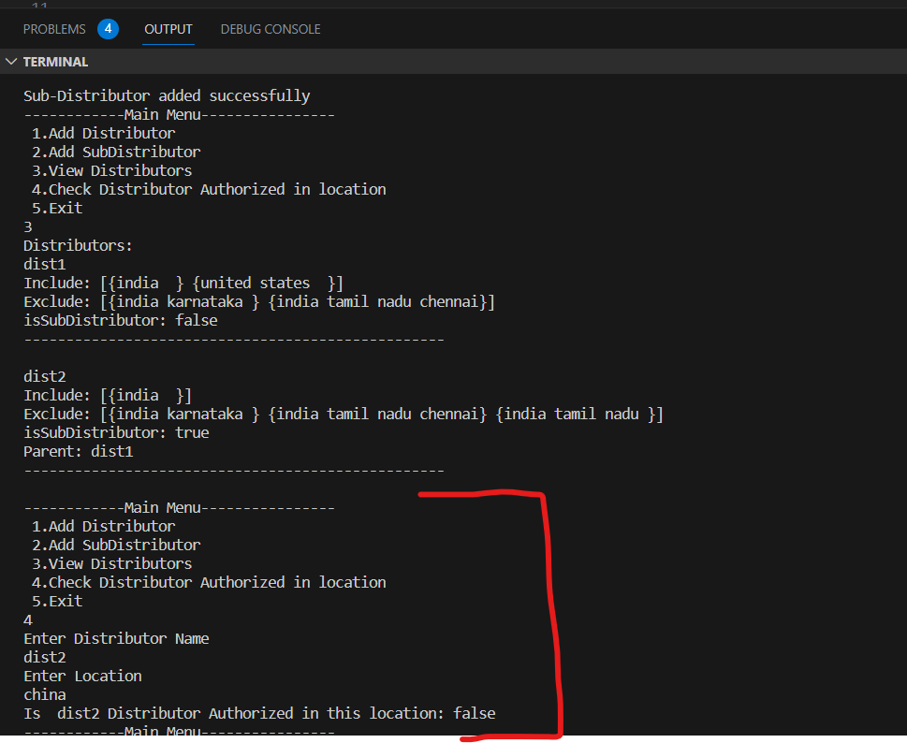

5)Creating subdistributor 3 when parent distributor is not authorized to location

